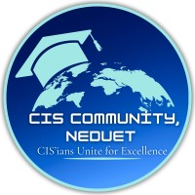

NED UNIVERSITY OF ENGINEERING AND TECHNOLOGY


N8N – SOCIAL MEDIA POSTING AUTOMATION

Submitted By:
Usman Rasheed Siddiqui
Noor Ul Ain

Table of Contents
1 Project Overview 3
2 End-to-End Benefits 3
3 How the Workflow Works 4
3.1 User Form Submission 4
3.2 Initial Validation & Classification 4
3.3 Approval Routing Logic 4
3.4 Admin Approval Stage 5
3.5 Social Media Posting 5
3.6 Error Handling & Logging 5
3.7 Final Status Update & Tracking 6
4 Future Enhancements 6
5 Workflow Working Snapshots 7
5.1 Form Filling 7
5.2 Automated Google Sheet Appending 7
5.3 Approval For Social Media Posting 8
5.4 Successful Post on Platforms 8
5.4.1 Instagram 8
5.4.2 LinkedIn 9
5.4.3 Facebook 9
5.4.4 Event Log Update 9

Project Overview
This project implements an n8n-based Social-Media Posting Automation Workflow designed to streamline, validate, approve, and publish content across multiple social media platforms.
The workflow ensures that all posts follow organizational guidelines through structured approvals, automated checks, and error handling before being published.
The system supports official and non-official posts, integrates approval hierarchies, and enables seamless posting to Instagram, Facebook, and LinkedIn with proper caption formatting and media validation.
Additionally, it provides real-time feedback to users when errors occur, helping maintain content quality and compliance.

End-to-End Benefits
- Centralized Social Media Management
Single workflow to manage posting across multiple platforms.
- Structured Approval Process
Reduces the risk of unauthorized or incorrect content being published.
- Rule-Based Validation
Automatically enforces official post guidelines (image dimensions, format, content rules).
- Real-Time Error Feedback
Sends email notifications to users when:
  - Images are private or invalid
  - URLs are incorrect or not from Google
  - Any other issue occurs during the workflow
This ensures users are aware of mistakes and can correct them promptly.
- Time Efficiency
Eliminates manual back-and-forth between content creators and administrators.
- Error Handling & Reliability
Detects and manages failures gracefully without breaking the workflow.
- Transparency & Tracking
Updates Google Sheets with:
  - Form submissions (media link, platform, status, post type)
  - Event logs (post IDs, success/failure, timestamps)
Each post has a unique ID for tracking and updates during the workflow.
- Flexible Content Formatting
Supports:
  - Bullet points
  - Paragraph-based captions
  - Platform-specific caption formats

How the Workflow Works

User Form Submission
- The workflow begins by prompting the user to fill out a Google Form containing:
  - Post content
  - Caption text
  - Platform selection (Instagram, Facebook, LinkedIn)
  - Post type (Official / Non-Official)
  - Image or media upload

Initial Validation & Classification
- Checks whether all required fields are filled.
- Determines if the post is Official or Non-Official.
- Validates media links:
  - Detects invalid or private Google URLs
  - Verifies image dimensions for official posts
- If an error occurs (invalid URL, private media, wrong coordinates, etc.):
  - Sends an email to the user explaining the issue
  - Prompts the user to correct and resubmit
  - Updates the tracking sheet with the error status

Approval Routing Logic
For Official Posts
- Verifies image size and coordinates according to official posting guidelines.

- If requirements are met:
  - Post moves to the next stage for admin review.
- If requirements fail:
  - Sends email to the user detailing the error.
  - Updates Google Sheet with status.
  - Stops or redirects for correction.
For Non-Official Posts
- Post is routed for admin review without strict image validation.

Admin Approval Stage
- Admin reviews the post:
  - If approved:
    - Workflow proceeds to social media publishing.
  - If rejected:
    - Email notification sent to the user.
    - Status updated in Google Sheet.

Social Media Posting
- Publishes posts on selected platforms:
  - Instagram
  - Facebook
  - LinkedIn
- Handles:
  - Caption formatting (paragraphs or bullet points)
  - Platform-specific requirements
  - Media upload and attachment

Error Handling & Logging
- Errors during posting (API failures, media issues, etc.) are:
  - Logged in the event log sheet
  - Email notifications sent to the user with details of the failure
  - Google Sheet updated with failure status

Final Status Update & Tracking
- Google Sheet is updated with:
  - Media link, platform, post status
  - Admin remarks
  - Publisher status
  - Event logs (post ID, timestamps, success/failure)
- Each post has a unique ID, ensuring all updates, corrections, or re-submissions are accurately linked and tracked.

Future Enhancements
The workflow is designed to be scalable and adaptable. Planned additions include:
- Multiple Photo Uploads
Allow users to upload more than one image per post, handling galleries or carousel formats.
- Scheduled Posting
Enable posts to be published at specific dates and times for better content planning.
- Comments Management
Automatically track, moderate, or respond to comments on published posts (subject to API capabilities).
- Mentions Handling
Detect and process mentions/tags in captions or comments (if social media APIs allow).
- Enhanced Error Handling & Logging
Include advanced checks for scheduled posts, multiple images, or API limitations.
- Scalable Reporting
Extend Google Sheets or event log to track additional attributes such as scheduled time, number of images, mentions, and comment actions.

Workflow Working Snapshots

Form Filling
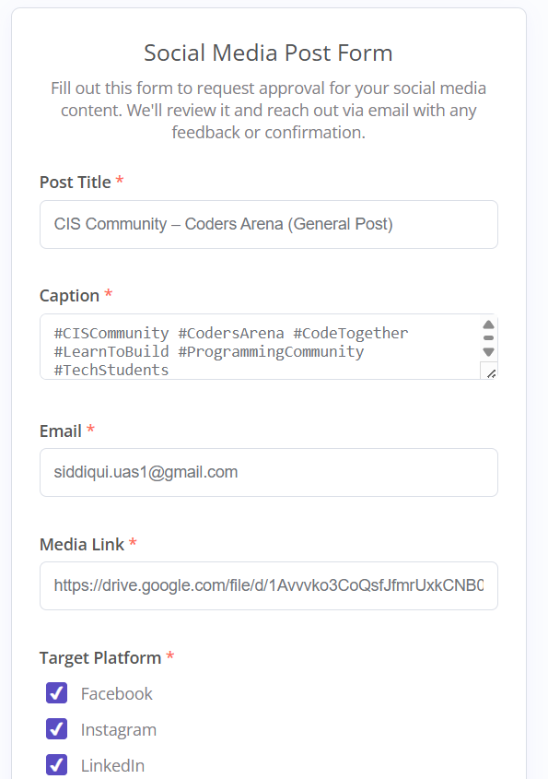
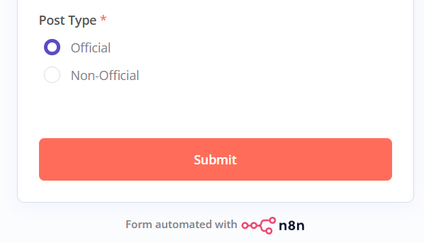
Figure 1: Form filling

Automated Google Sheet Appending
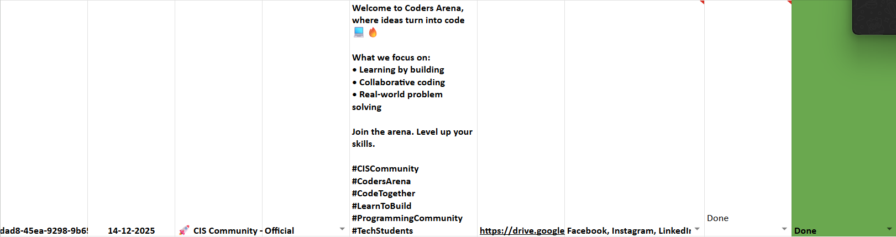
Figure 2: Sheet Update

Approval For Social Media Posting
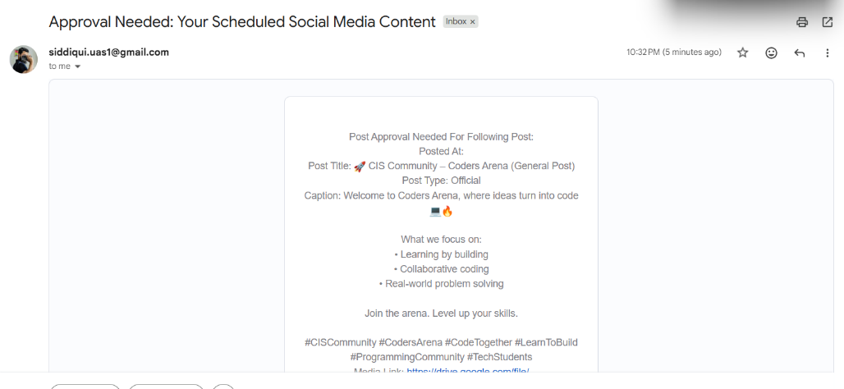
Figure 3: Approval Requirement

Successful Post on Platforms

Instagram
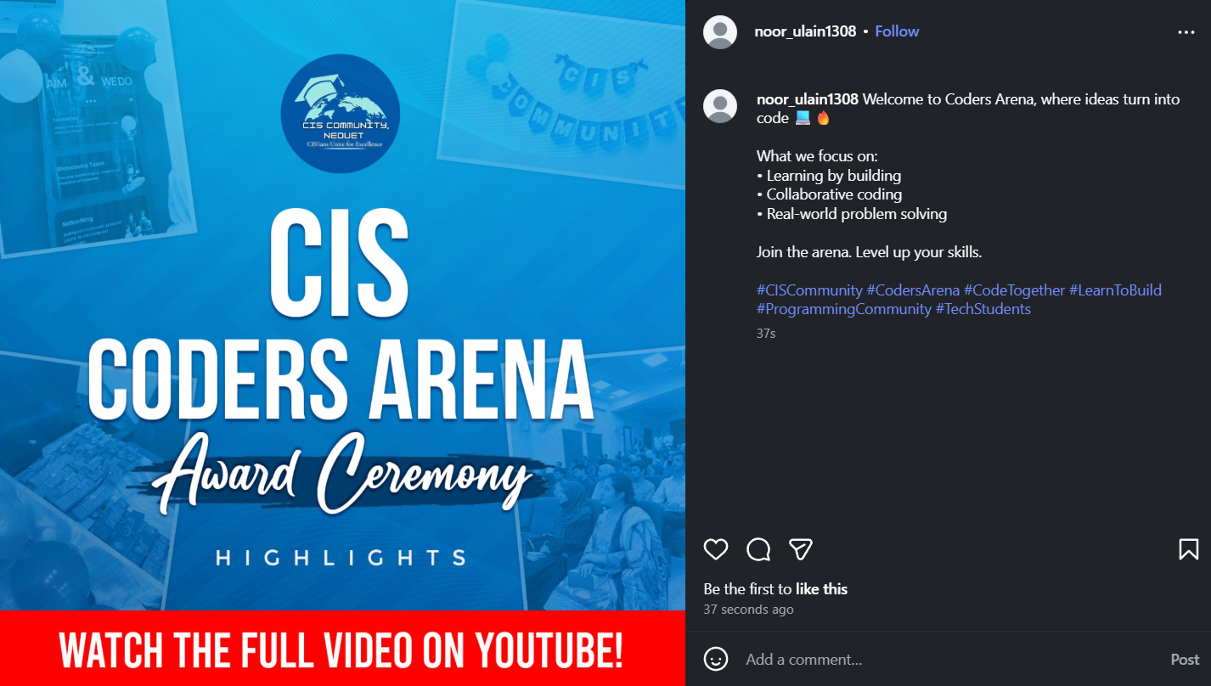
Figure 4: Instagram Successful Post

LinkedIn
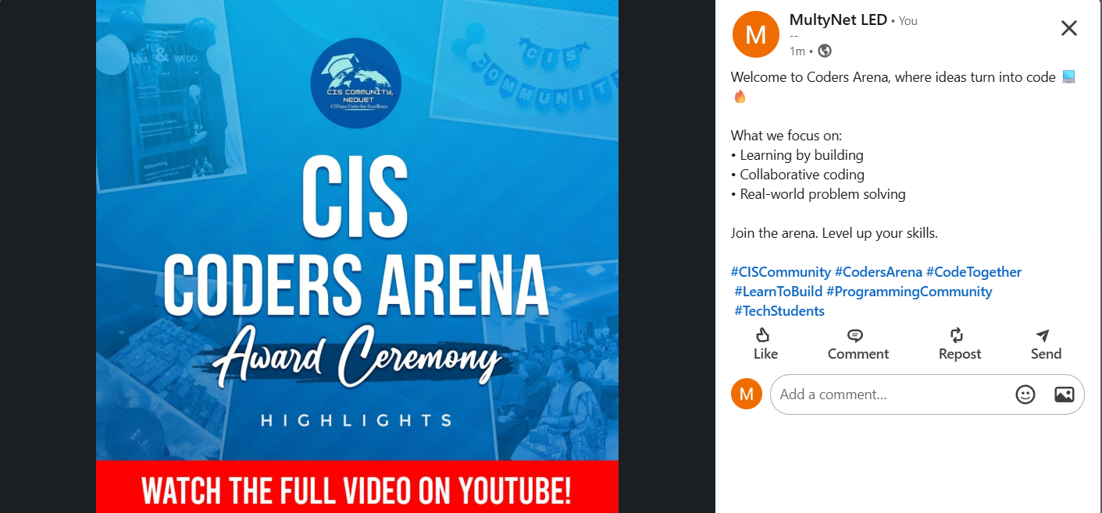
Figure 5: LinkedIn Successful Post

Facebook
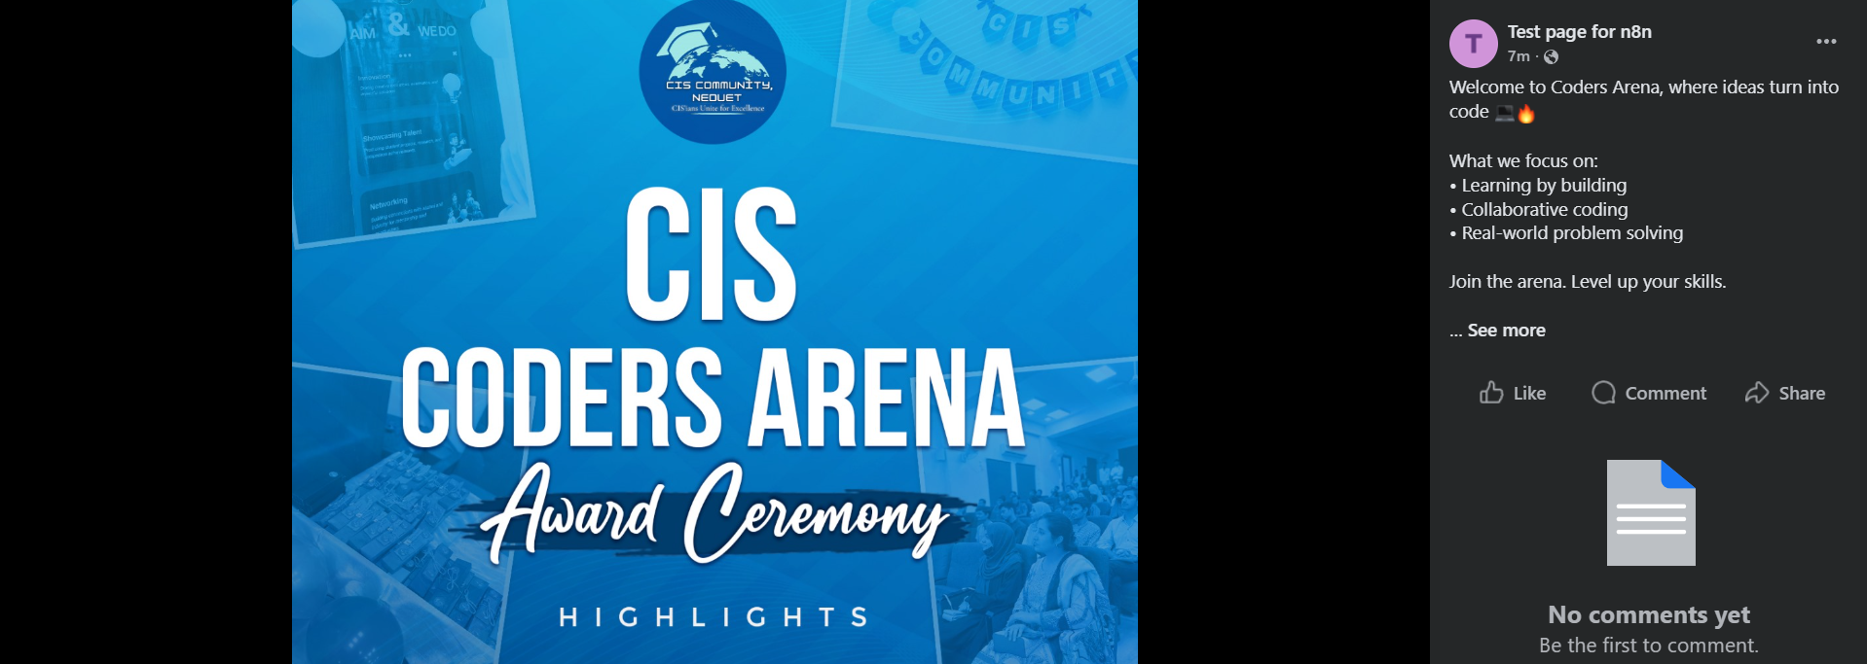
Figure 6: Facebook Successful Post

Event Log Update

